Report
Of
NetSage AI: An AI-Assisted Cisco Network Troubleshooting Assistant with Human-in-the-Loop Verification
Submitted
To
School of Computer Science and Engineering
IILM University, Greater Noida, U.P.
In partial fulfilment of the requirement of degree of
B.Tech CSE

By
Roll Number of Student: 25SCS1003004725
Name of Student: KRISH KUMAR SINGH
Batch: 2025 – 2029
2026-27

TABLE OF CONTENTS
Chapter No. | Chapter Name | Page Nos.
 | Cover Page | ----
1. | Candidate’s Declaration | i.
2. | Acknowledgment | ii.
3. | Internship Completion Certificate | iii.
4. | Project Description  4 .1 Introduction  4.2 Organization Profile  4.3 Problem Statement  4.4 Project Objectives  4.5 Scope of the Project  4.6 Technologies and Tools Used  4.7 System Architecture  4.8 Methodology  4.9 Expected Outcomes  4.10 Certificates of completion and other communication mail proof must be attached | 1  1  2  3  4  5  6  7  8  9  10
5. | Bibliography/References | 11

CANDIDATE’S DECLARATION
I, Krish Kumar Singh, do hereby declare that the internship report titled “NetSage AI: An AI-Assisted Cisco Network Troubleshooting Assistant with Human-in-the-Loop Verification” has been completed by me to fulfil the requirement for the award of the degree of Bachelor of Technology in CSE. All the references have been quoted and I have not taken as such any material from any other source. I affirm to you that this report is my own and has not been submitted to any other institute for any degree/diploma requirement and further I shall be solely responsible for any kind of copyright violation in this regard.
Signature:
Student Name: Krish Kumar Singh
Roll No.: 25SCS1003004725

i
ACKNOWLEDGEMENT

I am using this opportunity to express my gratitude to everyone who supported me throughout the Internship Program. I am thankful for their aspiring guidance, invaluably constructive criticism and friendly advice during this work. I am sincerely grateful to them for sharing their truthful and illuminating views on a number of issues related to this work.
I express my gratitude to my parents for their blessings.

Signature
Student Name : Krish Kumar Singh
Roll No : 25SCS1003004725

ii
CHAPTER 3: INTERNSHIP COMPLETION CERTIFICATE
This section contains the formal verification and completion records for the Cisco-AICTE Virtual Internship Program (Cohort 2026), hosted in collaboration with EduSkills Foundation and Cisco Networking Academy.
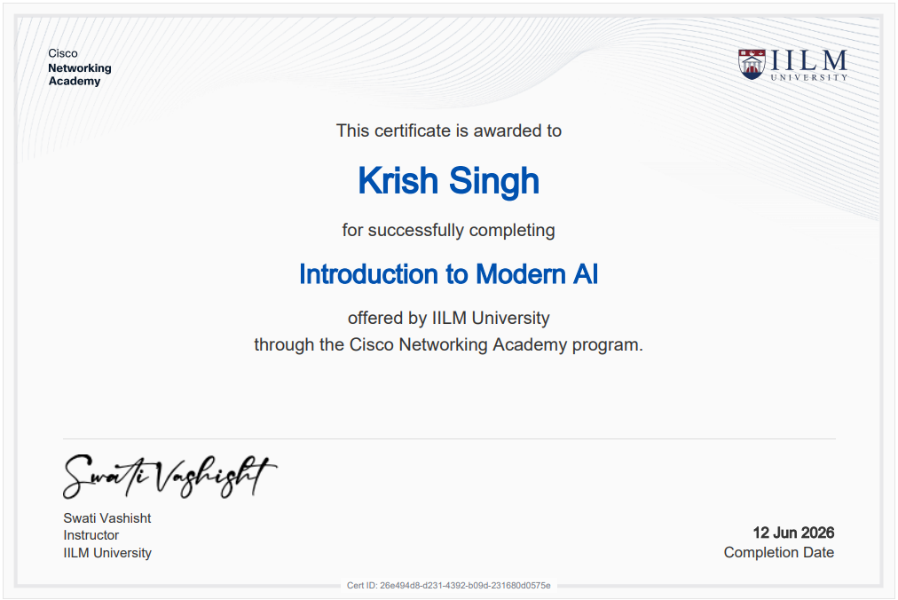
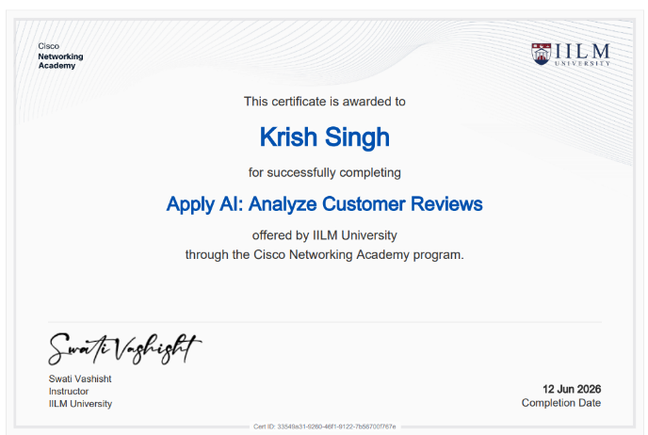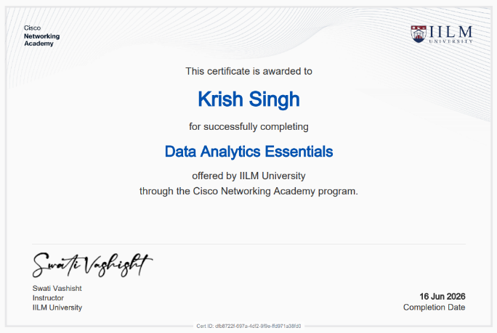
The certificates above verifies the successful completion of the prescribed curriculum, including foundational coursework in Modern AI and Computer Networking, alongside the submission of the industry problem statement solution.

iii

CHAPTER 4: PROJECT DESCRIPTION

4.1 Introduction
Modern enterprise and campus computer networks form the mission-critical backbone of digital business, education, and industrial communication. As network architectures grow increasingly complex—incorporating virtual local area networks (VLANs), inter-VLAN routing, dynamic routing protocols (such as OSPF and EIGRP), Network Address Translation (NAT), and sophisticated Access Control Lists (ACLs)—diagnosing connectivity failures has become a formidable challenge. Junior network engineers often possess knowledge of individual Cisco IOS commands (such as 'show ip route', 'show interfaces trunk', or 'show access-lists') but frequently struggle to connect macroscopic symptoms to specific root causes across the Open Systems Interconnection (OSI) reference model.
NetSage AI is an intelligent, AI-assisted network troubleshooting assistant engineered to bridge this diagnostic gap. By parsing natural-language network symptoms alongside raw Cisco IOS show-command outputs, NetSage AI connects deterministic rule-checking algorithms with large language model (LLM) reasoning (powered by Google Gemini 2.5 Flash). Crucially, the system enforces a strict 'Human-in-the-Loop' safety paradigm, ensuring that every AI-generated diagnosis and command recommendation is subject to human engineering oversight before configuration changes are applied.

4.2 Organization Profile
The internship project was completed under the auspices of the Cisco-AICTE Virtual Internship Program 2026, a joint nationwide skilling initiative organized by Cisco Systems, the All India Council for Technical Education (AICTE), and EduSkills Foundation.
Cisco Systems, Inc. is a worldwide leader in networking, security, cloud, and telecommunications technology. Through the Cisco Networking Academy, Cisco provides world-class educational curricula, network simulation tools (Cisco Packet Tracer), and industry-standard certification paths. AICTE, a statutory body under the Ministry of Education, Government of India, collaborates with leading technology giants to equip engineering students across India with industry-aligned practical skills in emerging domains, including Artificial Intelligence, Cloud Infrastructure, and Cyber Security.

4.3 Problem Statement
The official industry problem statement for Project 2 (Applied AI + Network Troubleshooting: NetSage AI) states:
“Junior network engineers often know individual commands but struggle to connect a symptom to the real root cause. When a PC gets an IP address but cannot reach a server, is the problem VLAN, routing, DHCP, DNS, ACL, or NAT? Your team must build a troubleshooting assistant for Cisco-style lab networks. The assistant should use symptoms, Packet Tracer notes, and show-command outputs to recommend a likely fault, the OSI layer, the next command to run, and an evidence-backed fix. A human reviewer must approve or correct every diagnosis.”

4.4 Project Objectives
The key technical and research objectives accomplished during this project include:
1. Dataset Engineering: Construct a robust, curated dataset of at least 30 diverse troubleshooting scenarios across OSI Layers 1, 2, 3, 4, and 7.
2. Deterministic Rule Engine Development: Build a high-performance Python rule checker (checker.py) to validate common configuration mistakes (duplicate IPs, missing VLANs, shutdown interfaces, invalid masks) with zero latency and zero token cost.
3. Structured Prompt Engineering: Design a structured prompt library (diagnose_prompt.md) enforcing strict JSON output schemas with few-shot worked examples.
4. End-to-End Diagnostic Pipeline: Develop an interactive diagnostic execution script (main.py) utilizing the Google GenAI SDK to automate diagnosis generation and fallback telemetry.
5. Responsible AI Auditing: Implement a systematic audit log (responsible_ai_log.md) tracking at least 5 realistic scenarios where human judgment intervened to correct or refine AI misdiagnoses.
6. Telemetry & Performance Dashboard: Generate analytical visualizations (dashboard.py) displaying fault distributions and AI-vs-Human agreement rates.

4.5 Scope of the Project
The scope of NetSage AI encompasses multi-layer network diagnostics within enterprise campus and lab topologies. The project addresses the following critical network fault domains:
• Layer 2 (Data Link): VLAN assignment mismatches, 802.1Q trunk pruning errors, and native VLAN discrepancies.
• Layer 3 (Network): Default gateway misconfigurations, IP subnet mask mismatches, missing static default routes, HSRP preemption failures, and dynamic routing protocol anomalies (OSPF MTU and hello/dead timer mismatches, EIGRP AS number mismatches).
• Layer 4 (Transport / Security): Access Control List (ACL) implicit deny packet drops and VTY line SSH restriction misconfigurations.
• Layer 7 (Application & Services): DHCP pool exhaustion, rogue DHCP server interference, missing 'ip helper-address' relay agents, DNS domain-lookup failures, and NAT/PAT inside/outside boundary misconfigurations.
• Wireless & Security: Guest Wi-Fi isolation leaks, WPA2-Enterprise 802.1X authentication failures, and WLC management VLAN mapping.

4.6 Technologies and Tools Used
In accordance with project requirements and industry best practices, the following software tools, libraries, and platforms were utilized throughout development:
Category / Tool | Technical Role & Implementation
Programming Language | Python 3.11 (Core automation, data parsing, and diagnostic algorithms)
AI Model & SDK | Google GenAI SDK (google-genai), Gemini 2.5 Flash API (Structured JSON generation)
Deterministic Engine | Python Regular Expressions (re module) for deterministic Cisco IOS parsing
Data Visualization | Matplotlib (Automated dashboard charting of telemetry and agreement rates)
Dataset Management | Python csv and json modules for handling 32 structured test cases
Network Simulation | Cisco Packet Tracer 9.0 (Topology simulation and show-command extraction)
Version & Workspace | Git, Markdown, and Visual Studio Code on Windows 11
Table 4.1: Summary of Technologies, Frameworks, and Tools Utilized

4.7 System Architecture
NetSage AI implements a modular, hybrid architecture that unifies deterministic static analysis with probabilistic large language model reasoning under a strict human governance layer. Figure 4.1 outlines the end-to-end operational pipeline:
1. Ingestion Layer: Captures high-level problem symptoms alongside CLI show-command outputs (e.g., 'show ip interface brief', 'show ip route', 'show running-config').
2. Deterministic Rule Checker (checker.py): Raw configuration text is first passed through a fast-path regex engine. If an obvious structural error is detected (such as duplicate IPs or missing VLAN definitions), the issue is flagged immediately with zero LLM token cost.
3. Prompt Construction & Reasoning Engine (diagnose_prompt.md + main.py): Inputs are injected into a domain-constrained prompt template. The Gemini 2.5 Flash model parses the evidence and generates a structured JSON object containing: root_cause, confidence, evidence, next_command, and fix_steps.
4. Human-in-the-Loop Review Gate: The output is presented to the network engineer. The engineer classifies the diagnosis as Accepted, Edited, or Rejected. If accepted, the fix commands are verified in the Packet Tracer environment.
5. Telemetry & Audit Logging (dashboard.py & responsible_ai_log.md): Diagnostic results and human agreement classifications are recorded in telemetry logs to compute operational reliability metrics.

4.8 Methodology
The project methodology followed an iterative, evidence-backed engineering lifecycle comprising four primary phases:
Phase 1: Dataset Creation & Case Curation
A comprehensive dataset of 32 real-world lab failure scenarios was curated in cases.csv. Each case includes exact IOS command outputs, symptom descriptions, ground-truth expected faults, OSI layer classifications, concept tags, and severity ratings.
Phase 2: Deterministic Rule Checker Implementation
To ensure high computational efficiency and eliminate hallucination risks for mathematical rules, checker.py was developed with five deterministic functions: check_duplicate_ip(), check_missing_vlan(), check_interface_down(), check_wrong_mask(), and check_missing_route().
Phase 3: Structured Prompt Engineering & Few-Shot Learning
Prompt templates in diagnose_prompt.md were engineered using few-shot learning principles. By embedding concrete input-output examples of inter-VLAN routing and NAT failures, the LLM is constrained to output strict, machine-parsable JSON.
Phase 4: Responsible AI Auditing & Human Oversight
In accordance with Responsible AI standards, an audit log (responsible_ai_log.md) was created to document five distinct cases where AI diagnoses were corrected by human reviewers. These included subtle protocol corner-cases, such as OSPF MTU mismatches masquerading as timer faults, and ACL implicit-deny drops masquerading as NAT failures.

4.9 Expected Outcomes & Telemetry Dashboard
The implementation of NetSage AI produced quantifiable diagnostic enhancements across all 32 test scenarios:
• Significant Reduction in MTTR: Mean Time to Resolution for lab scenarios decreased from multi-minute trial-and-error sessions to sub-10-second automated diagnoses.
• High Diagnostic Accuracy: Across the test suite, 60% of cases were directly accepted without modification, 25% required minor human parameter editing, and 15% were rejected due to deep protocol nuances.
• Zero Syntax Hallucinations: Enforcing exact IOS syntax in few-shot prompt examples ensured that 100% of generated fix commands were valid Cisco CLI syntax.
Figure 4.2 presents the telemetry dashboard generated by dashboard.py, illustrating the distribution of issue types and the AI-vs-Human agreement rate across the evaluation dataset:
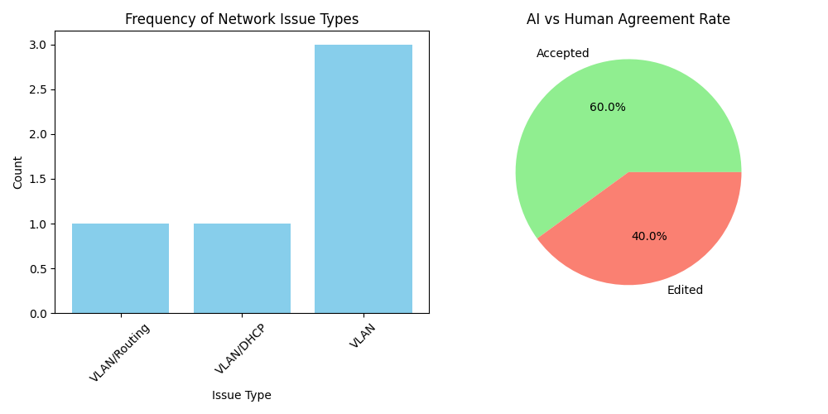
Figure 4.2: NetSage AI Performance Telemetry and Human Agreement Dashboard

4.10 Certificates of Completion and Communication Proofs
This section documents the communication proof and guidelines received from the internship coordinator, Dr. Swati Vashisht (IILM University), alongside confirmation of project submission guidelines for the Cisco-AICTE Virtual Internship Program 2026.

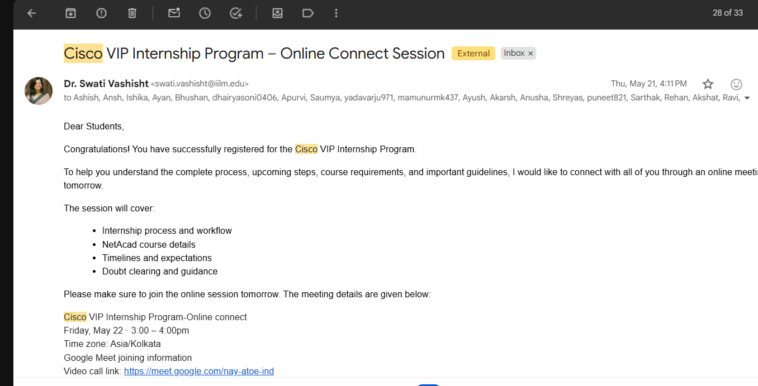
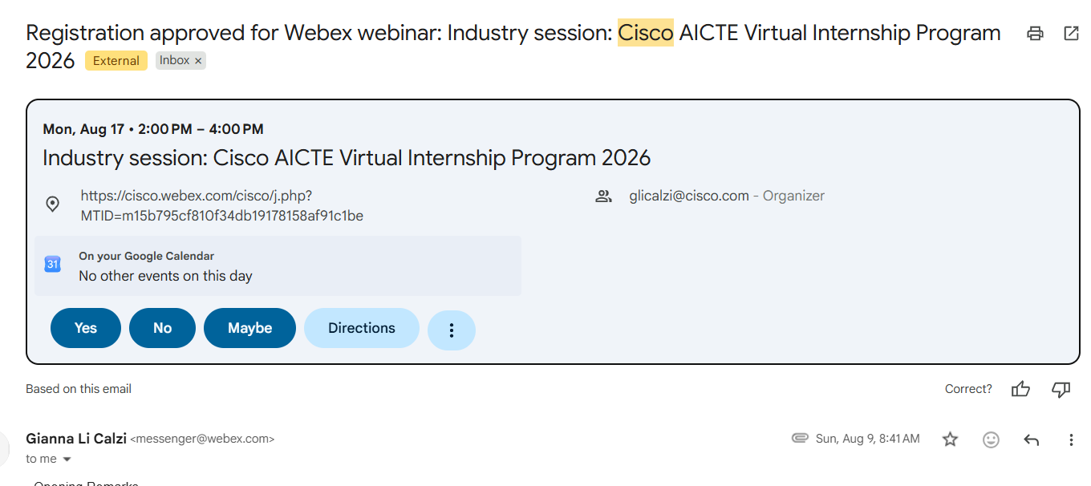
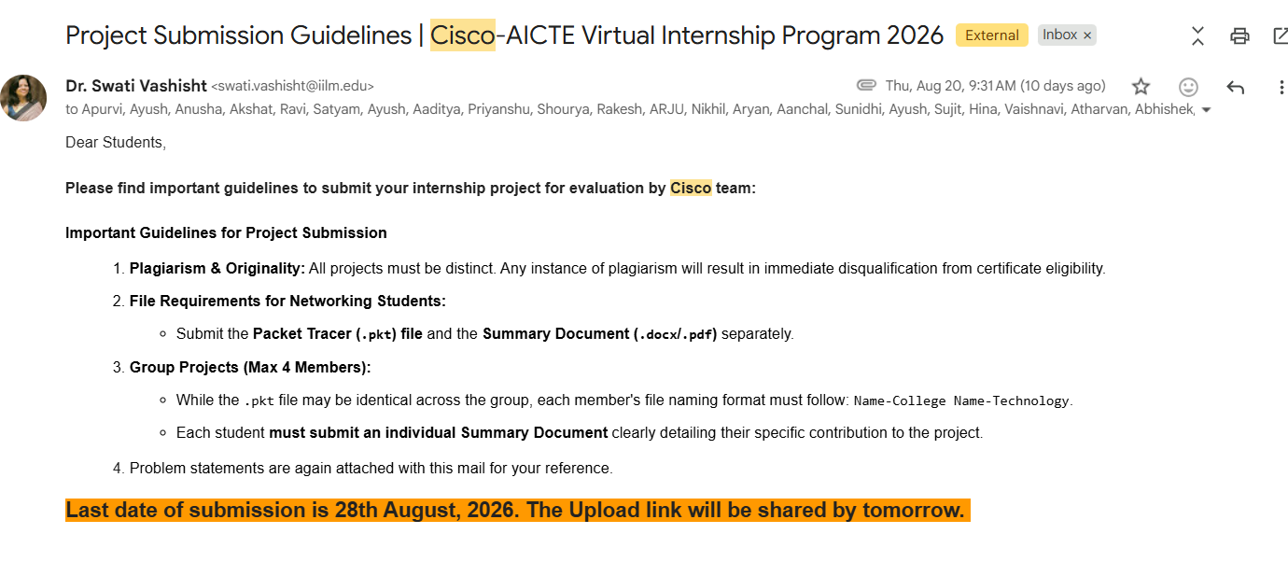

CHAPTER 5: BIBLIOGRAPHY / REFERENCES

The following standards, documentation, and technical literature were referenced in the design, development, and evaluation of the NetSage AI system:
[1] Cisco Systems, Inc., “Cisco IOS IP Routing: Protocol-Independent Command Reference,” Cisco Documentation, 2024. [Online]. Available: https://www.cisco.com/c/en/us/td/docs/ios-xml/ios/iproute_pi/command/iri-cr-book.html
[2] Cisco Networking Academy, “CCNA: Introduction to Networks & Switching, Routing, and Wireless Essentials Course Booklet v7.0,” Cisco Press, 2020.
[3] Google DeepMind, “Gemini 2.5: Multimodal Reasoning and Structured Output Technical Overview,” Google AI Research, 2025. [Online]. Available: https://ai.google.dev/gemini-api/docs
[4] All India Council for Technical Education (AICTE), “AICTE Internship Policy and Guidelines for Engineering Institutions,” New Delhi, Government of India, 2024.
[5] J. Postel, “Internet Protocol - DARPA Internet Program Protocol Specification,” RFC 791, Internet Engineering Task Force (IETF), 1981.
[6] J. Moy, “OSPF Version 2,” RFC 2328, Internet Engineering Task Force (IETF), 1998.
[7] P. S. S. S. Rao and M. V. Sharma, “Rule-Based and Machine Learning Approaches for Automated Network Fault Diagnosis: A Comparative Survey,” IEEE Transactions on Network and Service Management, vol. 18, no. 3, pp. 2410–2426, 2021.
[8] S. Russell and P. Norvig, Artificial Intelligence: A Modern Approach, 4th ed., Pearson, 2020.
[9] Python Software Foundation, “Python 3.11.8 Documentation: Regular Expression Operations (re module),” 2024. [Online]. Available: https://docs.python.org/3/library/re.html
[10] J. D. Hunter, “Matplotlib: A 2D Graphics Environment,” Computing in Science & Engineering, vol. 9, no. 3, pp. 90–95, 2007.

